**Sign Up/ Registration:**

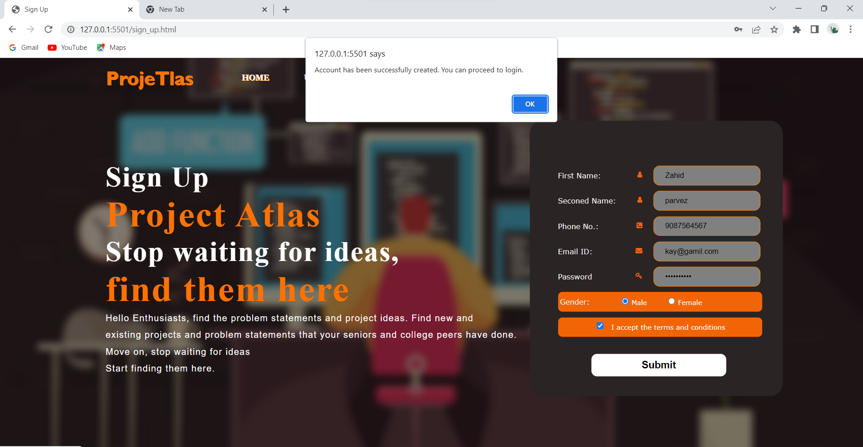

**Authorized and Authentication of user:**

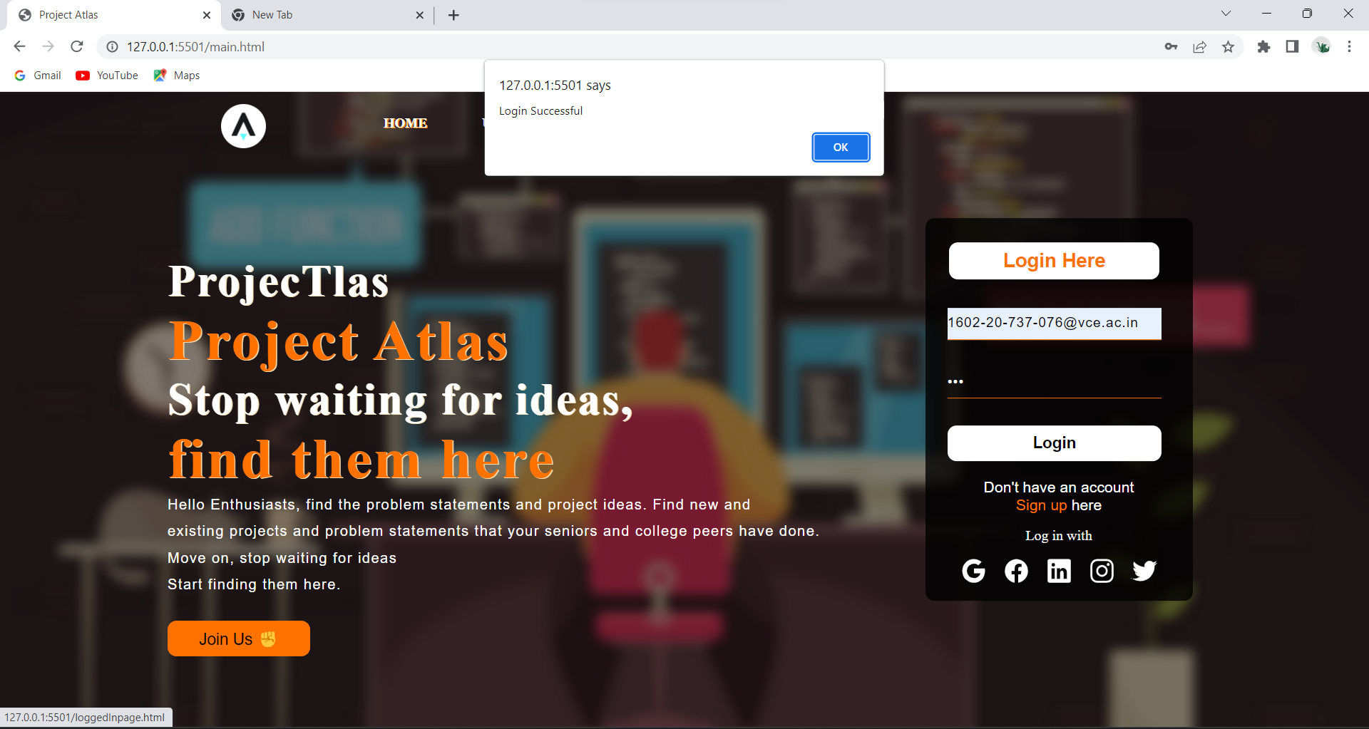

**Failed Login:**

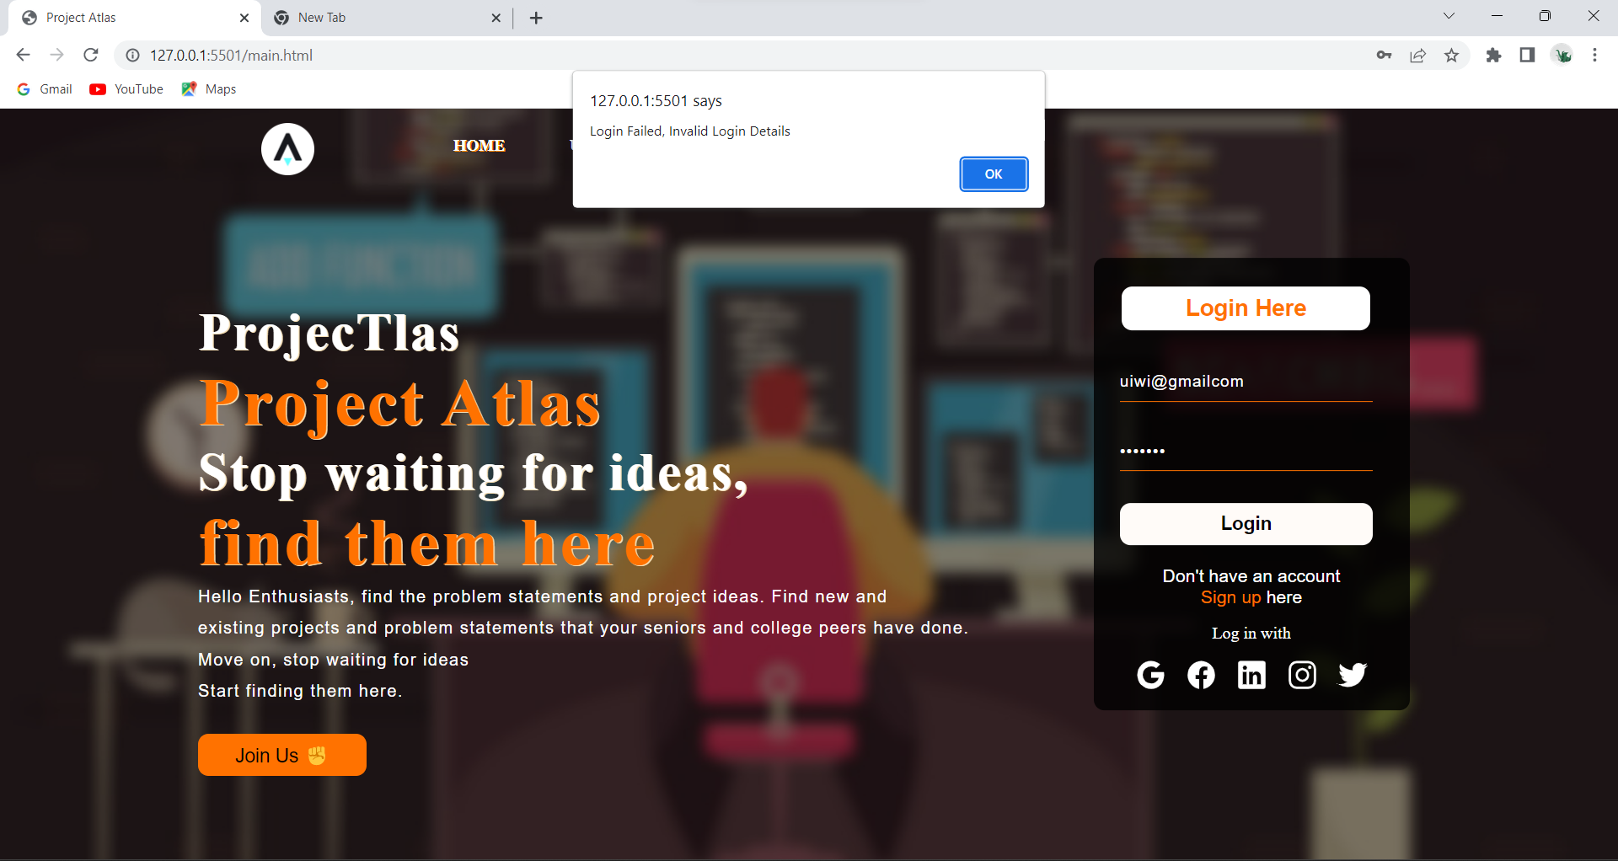

**Search:**

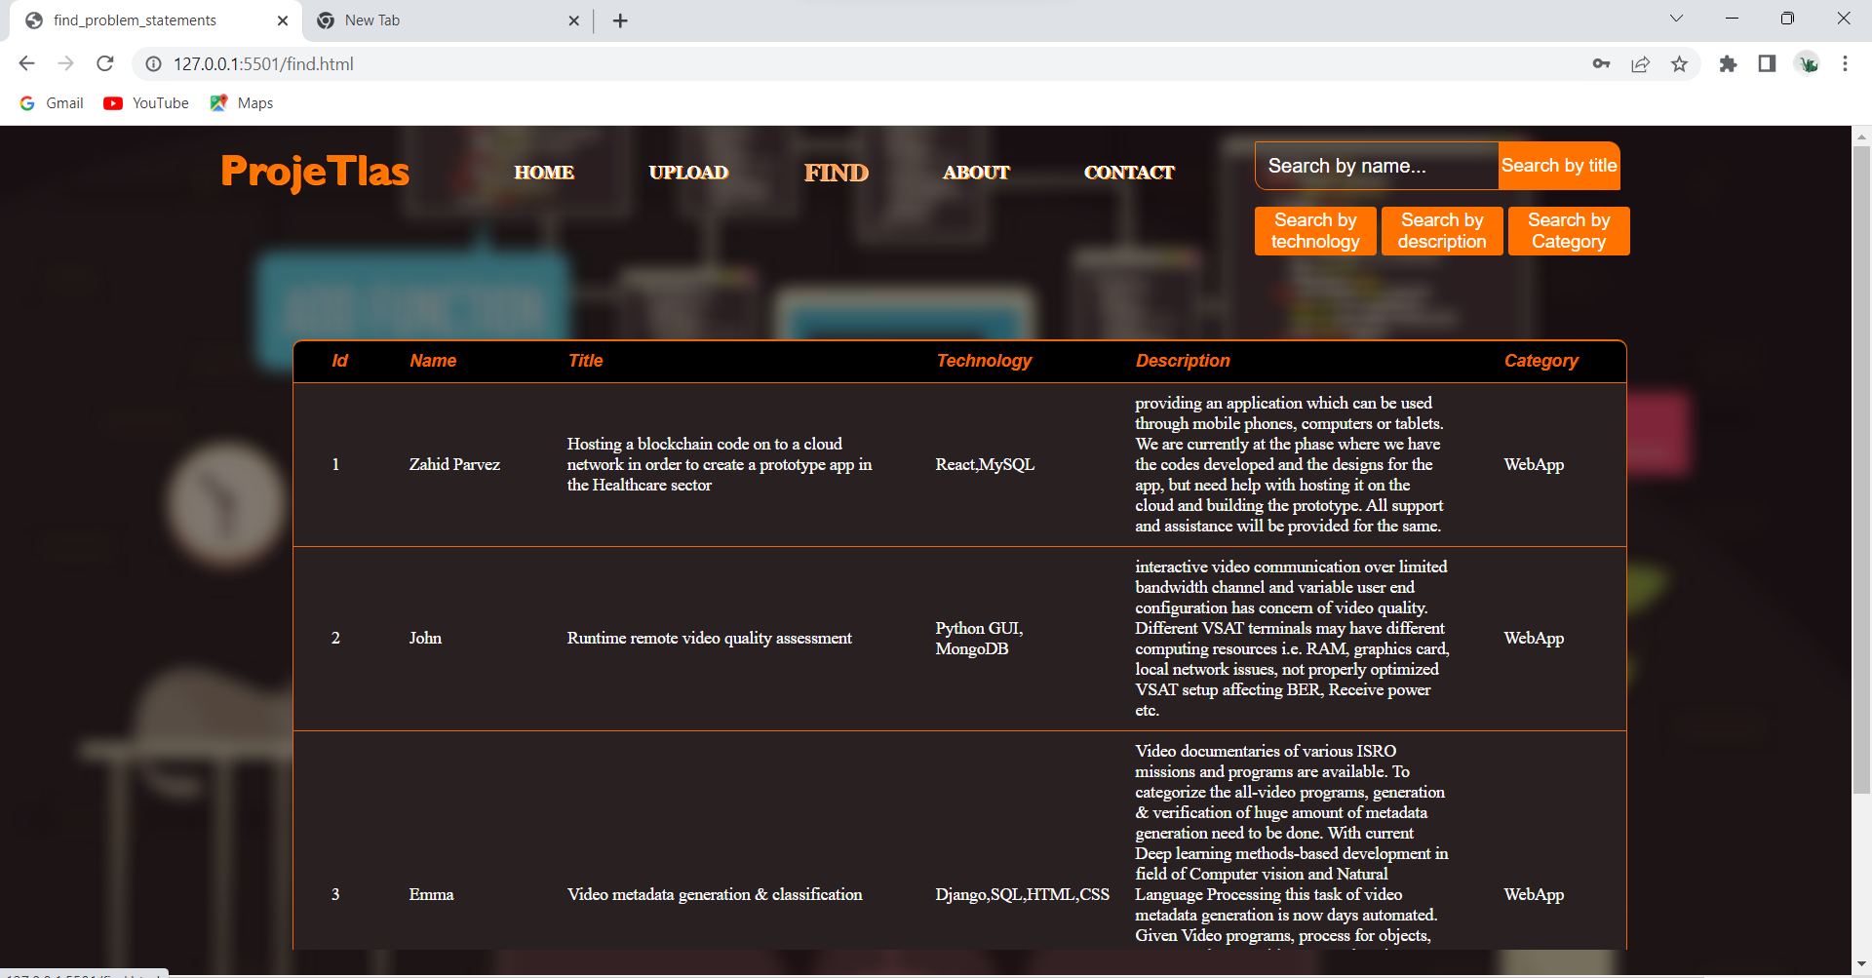

**Search by name(uploader):**

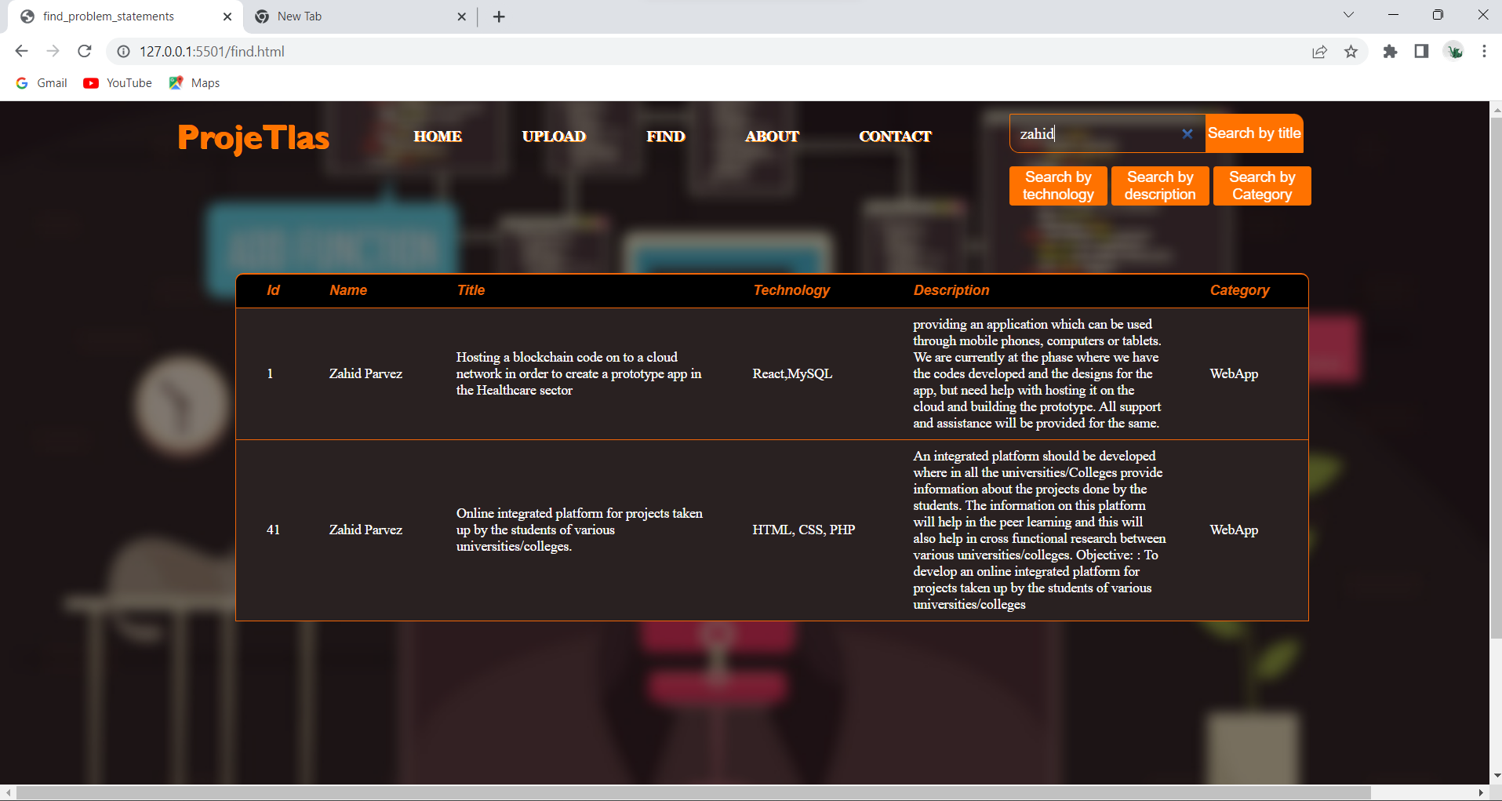

**Search By Category:**

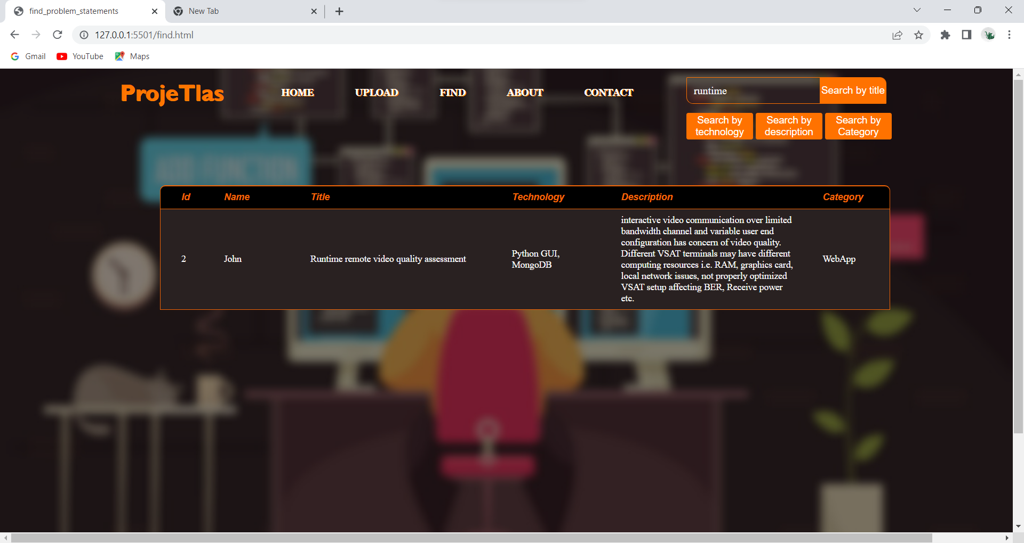

**Search By Description:**

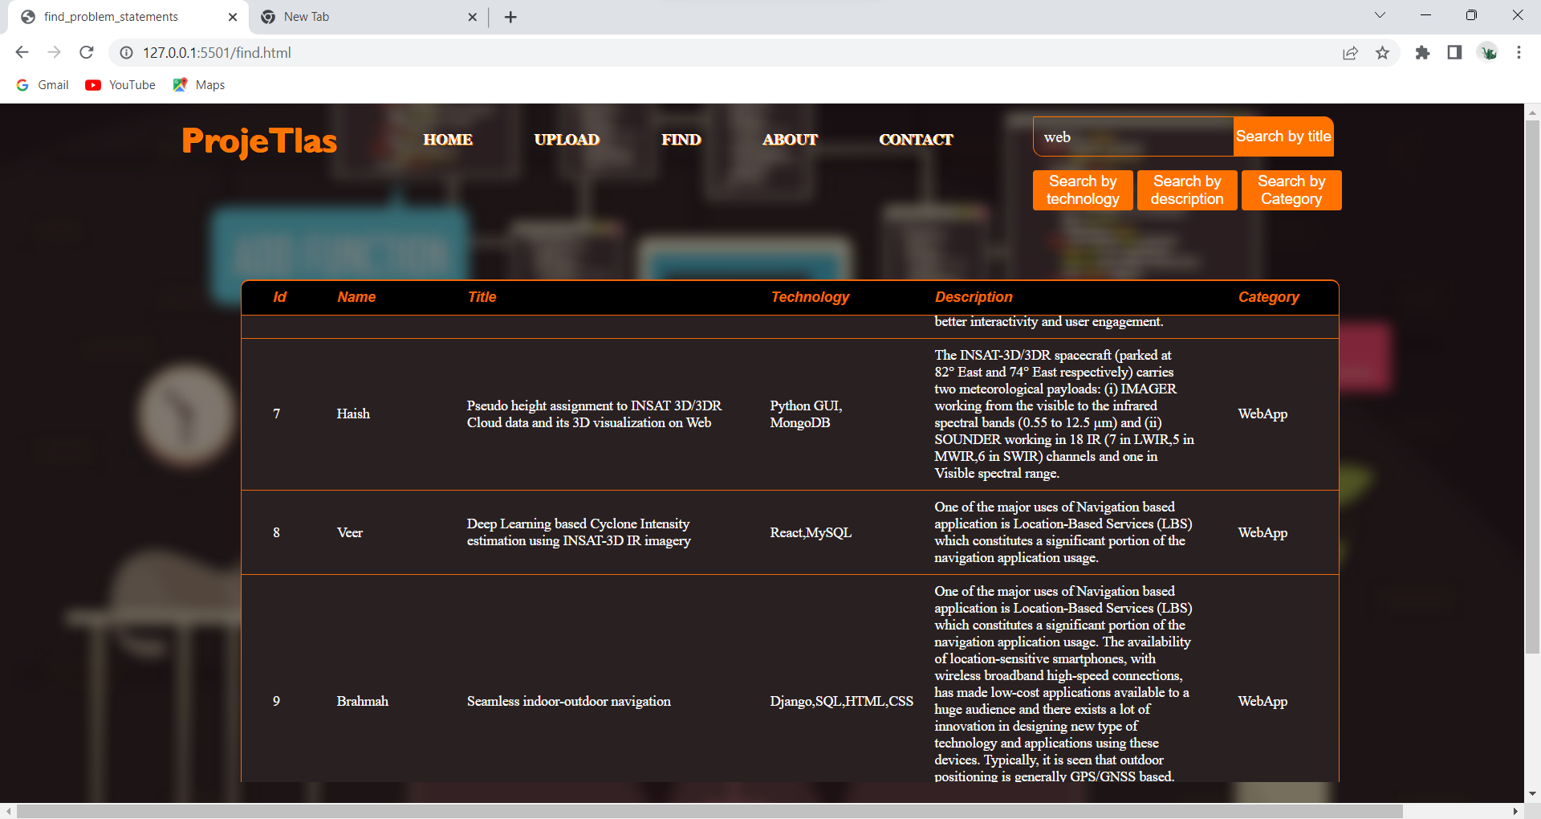

**Search By Technology:**

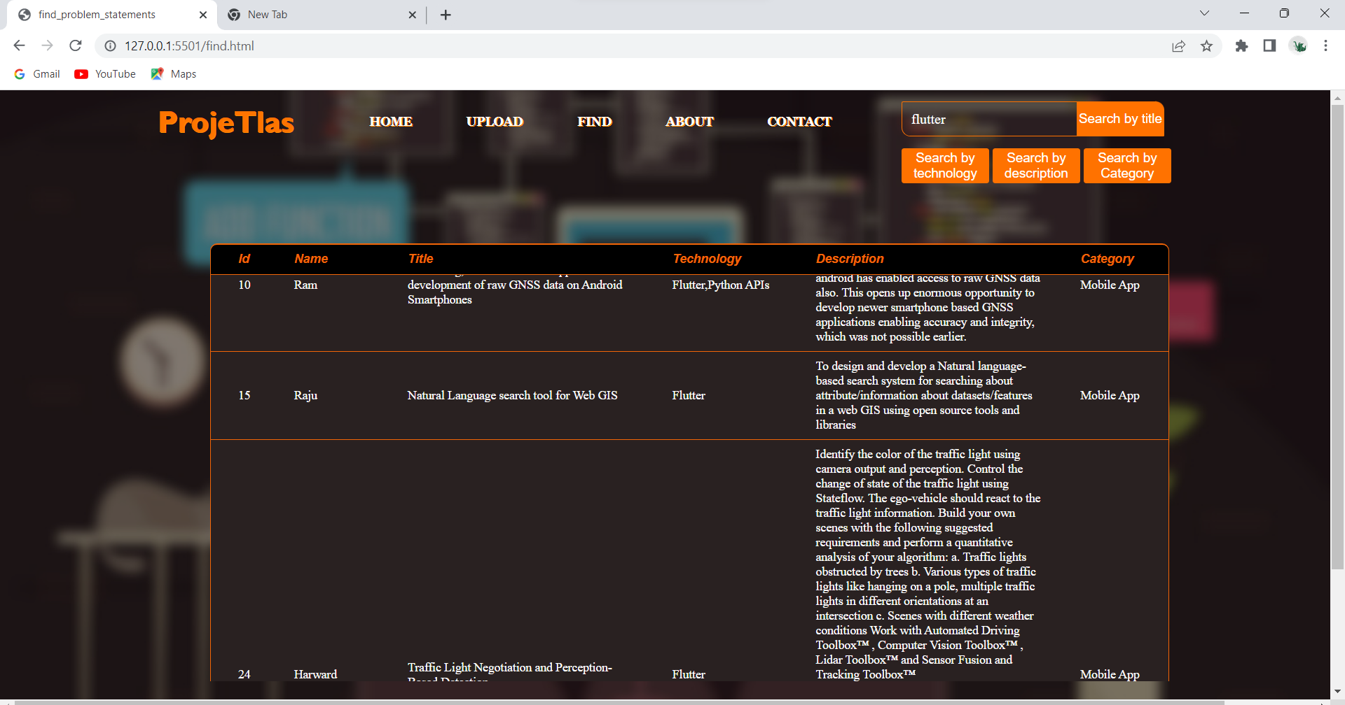

**Results**

**HOME PAGE SCREEN :**

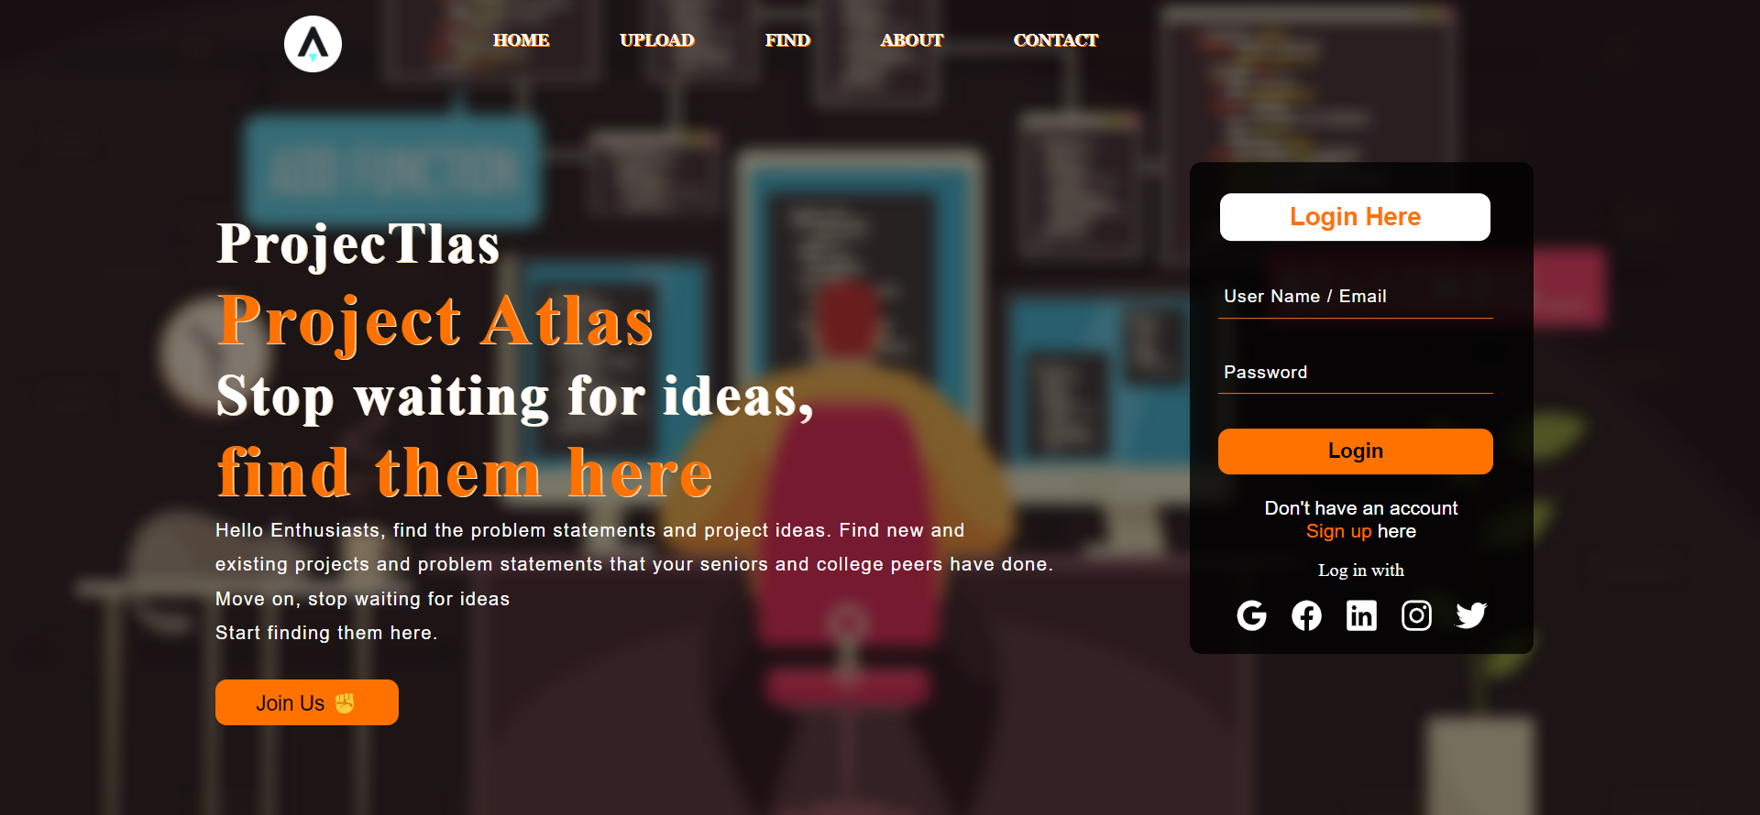

**SIGN UP SCREEN :**

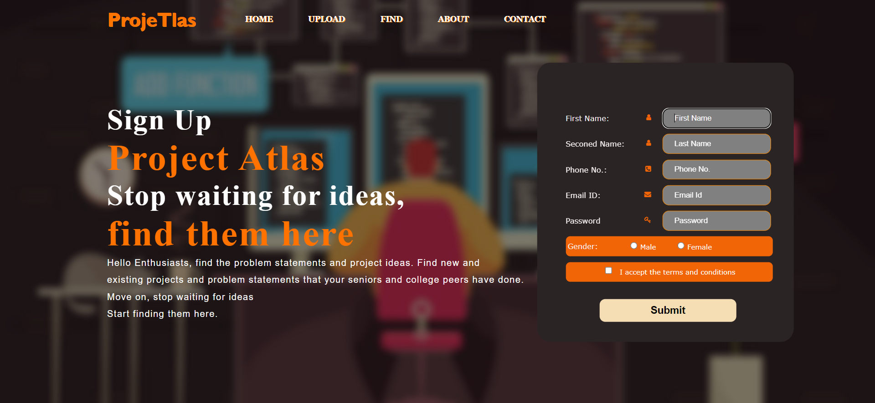

**LOGIN SCEEN :**



**USER PROFILE SCREEN :**

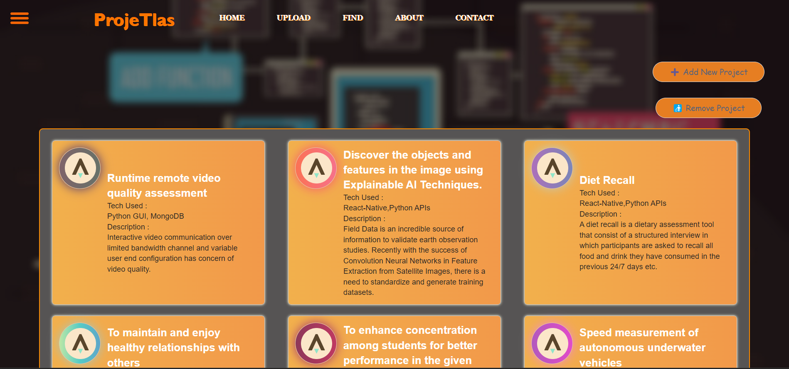

**FIND PROBLEM STATEMENT SCREEN:(Efficient search functions)**

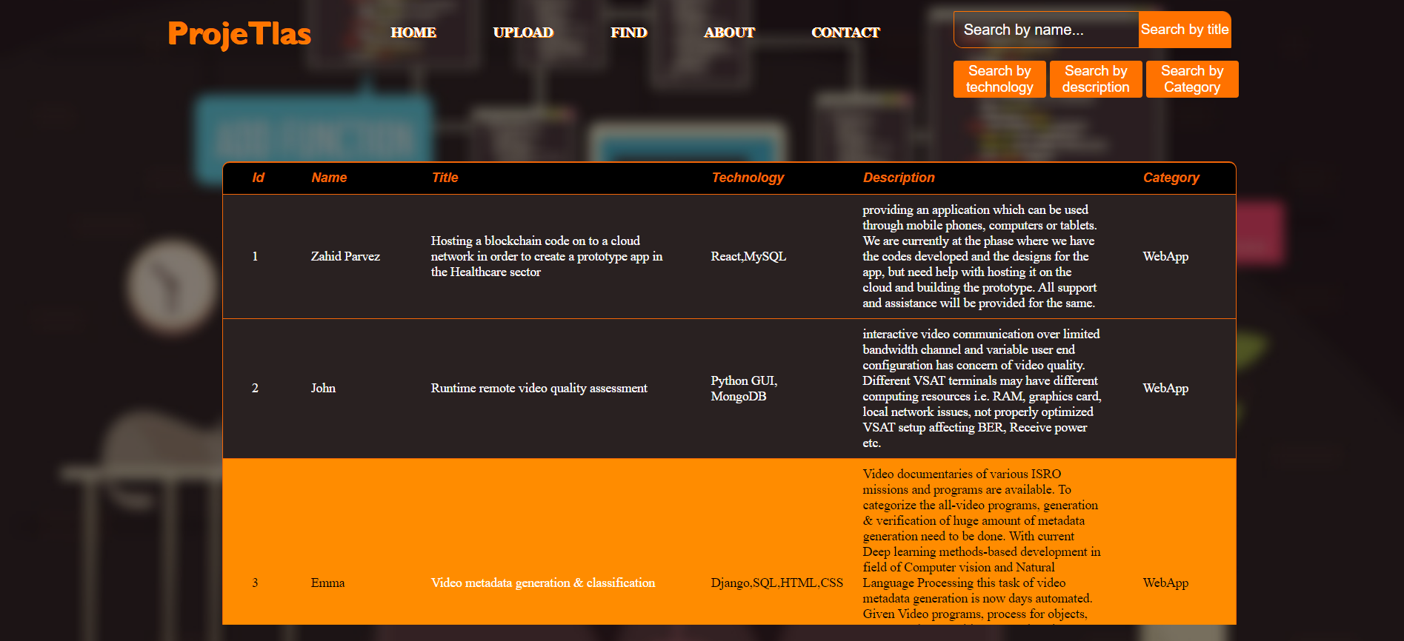

**ABOUT SCREEN:**

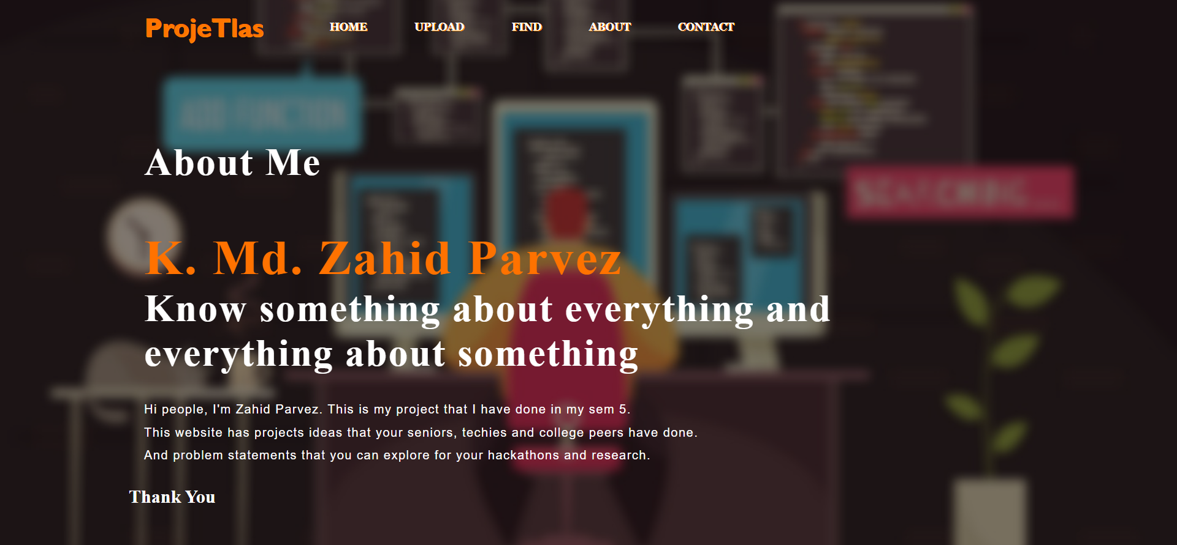

**CONTACT PAGE:**



**401 ERROR TEMPLATE:**

